Greedy switchbox router implementation

Algorithm based on:

Luk, Wing Kwong. "A greedy switch-box router." *Integration*3.2 (1985): 129-149.

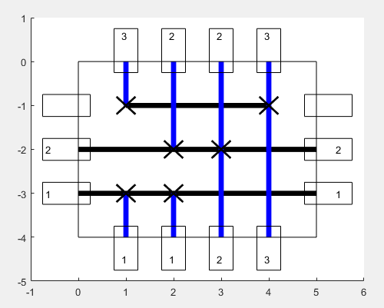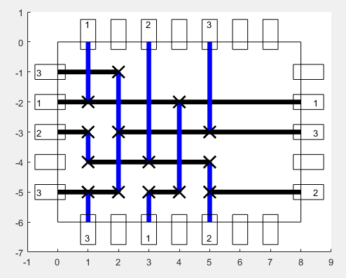

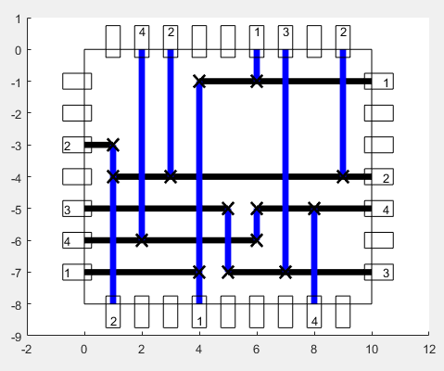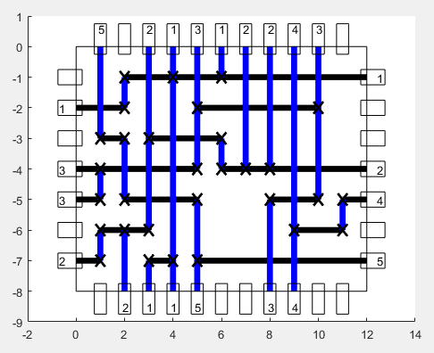

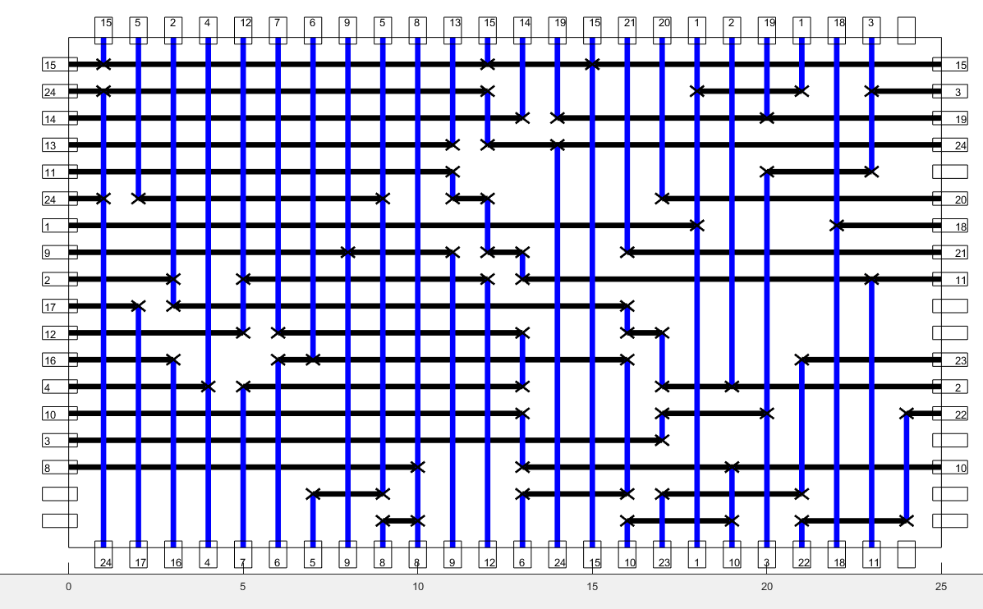

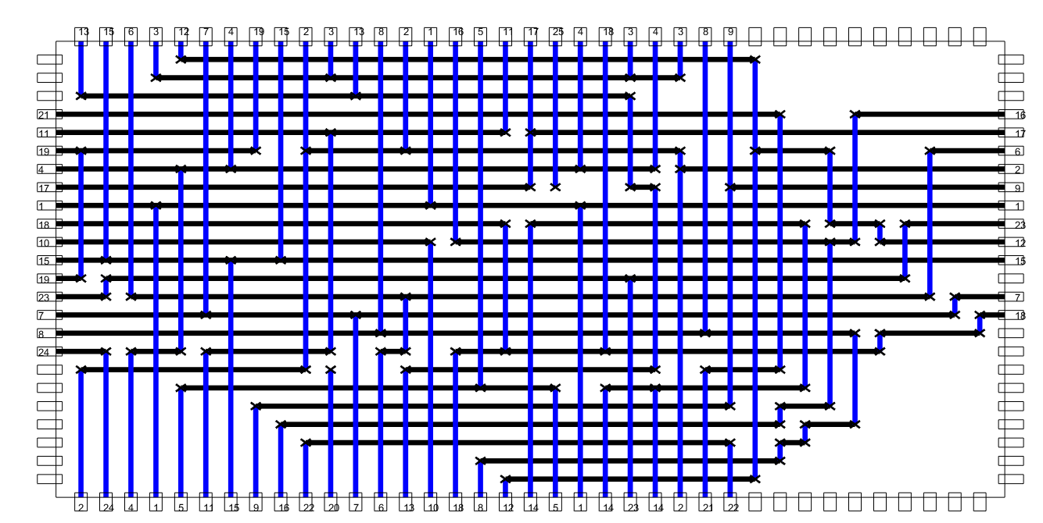

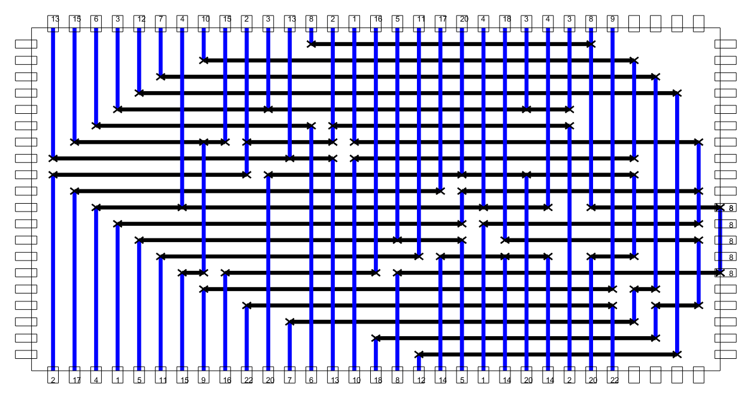

Burstein’s Difficult Switchbox

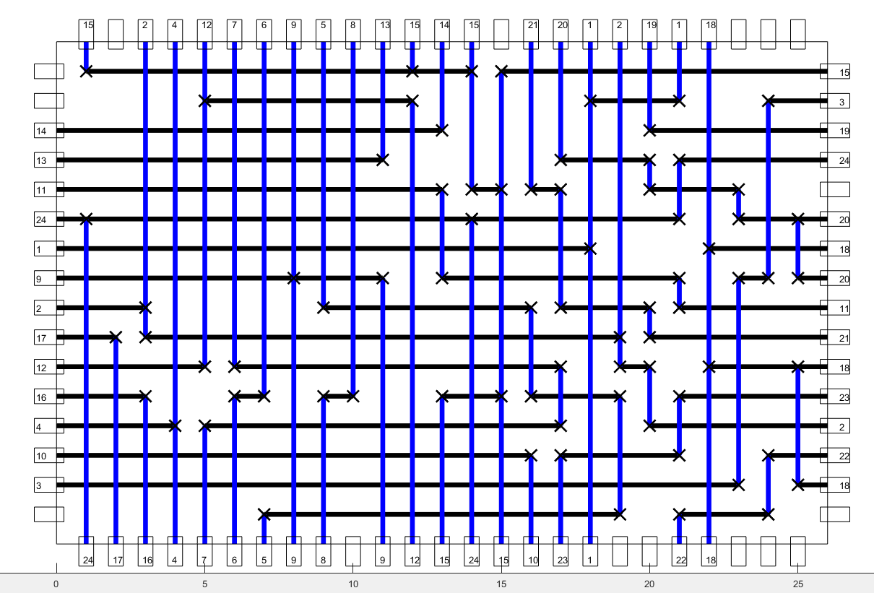

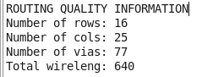

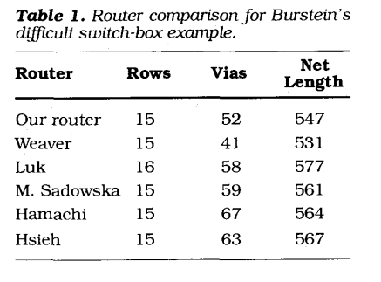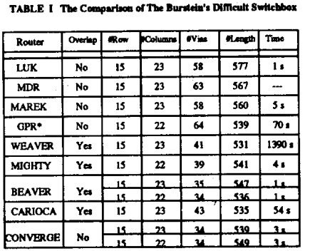

Deutsch’s Difficult Channel

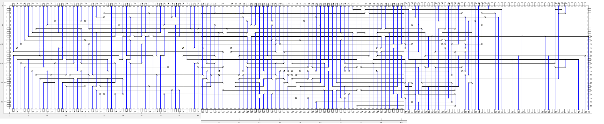



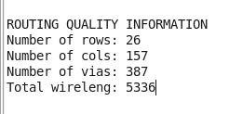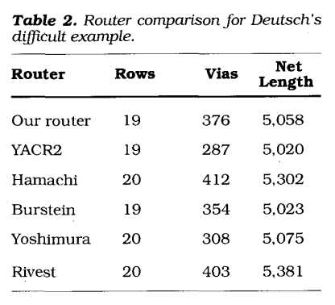Deutsch’s Difficult Channel

Conflict Resolution Switchbox Router

Algorithm based on:

Gerez, Sabih H., and Otto E. Herrmann. "PACKER: a switchbox router based on conflict elimination by local transformations." *IEEE International Symposium on Circuits and Systems,*. IEEE, 1989.

|  |  |  |
| --- | --- | --- |
| Test # | Greedy | Conflict |
| 1 |  |  |
| 2 |  |  |
| 3 |  |  |
| 4 |  |  |
| 5 |  |  |
| 6 |  |  |

Burstein’s

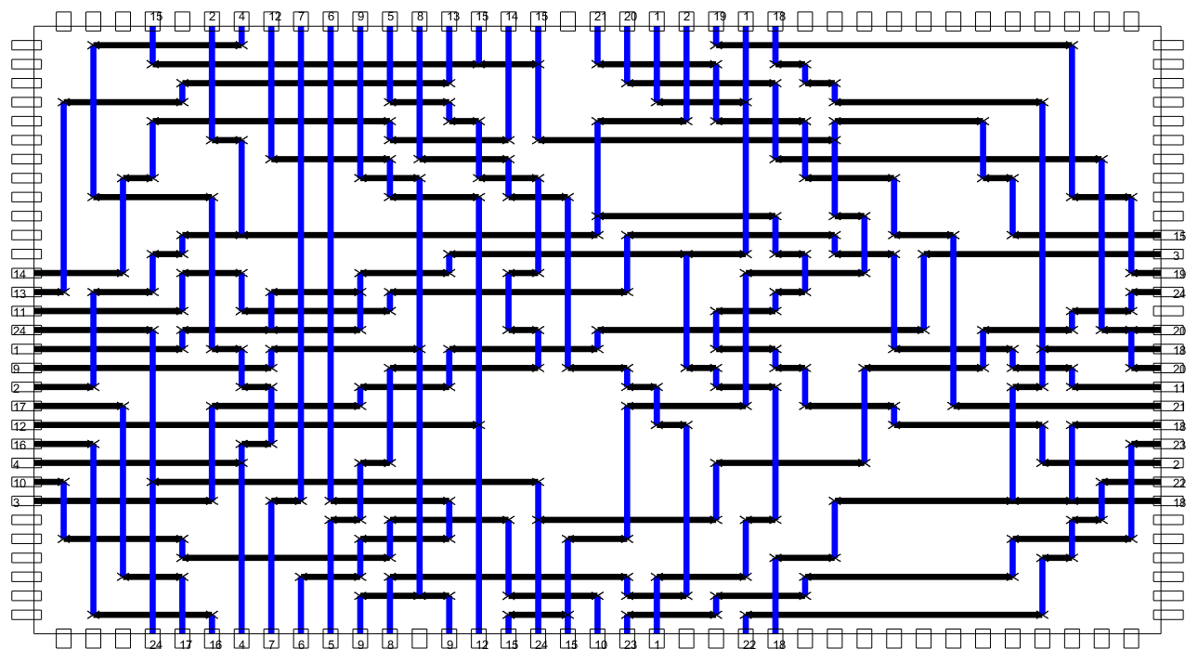

|  |  |  |  |
| --- | --- | --- | --- |
| ***Router*** | ***Rows*** | ***Vias*** | ***Wirelength*** |
| My greedy router | 16 | 77 | 640 |
| My conflict router | 31 | 251 | 1115 |
| Jou | 15 | 52 | 547 |
| Weaver | 15 | 41 | 531 |
| Luk | 15 | 58 | 577 |
| Sadowska | 16 | 59 | 561 |
| Hamachi | 15 | 67 | 564 |
| Hsieh | 15 | 63 | 567 |